Preface

This User Guide explains how to use the system to process Shipping Guarantees. It assumes that you are familiar with the basic principles of trade finance relating to clean bankers' acceptances, and with web browsers.

# About Shipping Guarantees

Shipping guarantees provide a method whereby an importer whose goods arrive before the document of title needed to claim them can nevertheless take possession of those goods and thus prevent spoilage or minimise storage charges.

The bank issues a shipping guarantee to the shipping company holding the goods, allowing them to release the goods to the importer without document of title by guaranteeing them recompense, should the document of title not arrive. When the document of title arrives, the bank sends it on to the shipping company and requests the return of the shipping guarantee for cancellation.

Shipping guarantees are created in one of two ways:

* As standalone transactions using a Create Shipping Guarantee event. The standalone guarantee can then be linked to a transaction at a later date
* Against a particular import letter of credit, using an Issue Shipping Guarantee event from within that letter of credit

Both events create a shipping guarantee master record, and for both events the actual shipping guarantee is produced once the event is released.

At a later date, when the document of title is received, the shipping guarantee is recalled from the shipping company using a Release event. The Release event can be created against the shipping guarantee master, or it can be created:

* For import letters of credit, from within the Claim Received or Outstanding Claim event
* For inward documentary collection orders, from within a Receive Documents event

Your bank can configure your system so that shipping guarantees can be issued either in respect of a single document of title or in respect of multiple documents of title. However, a Release event can process only one document of title; so where a shipping guarantee is in respect of multiple documents of title several Release events will be required and the shipping guarantee will not be returned until the final one has completed.

Your bank can link a standalone shipping guarantee that has more than one document of title to more than one transaction by selecting a separate document of title for each transaction.

A shipping guarantee is returned once the shipping company has taken delivery of all the document(s) of title recorded against it. Details of the returned shipping guarantee are entered into the system using a Return event against the shipping guarantee master.

For the rare situation where documents of title are never received and the shipping company makes a claim against the shipping guarantee the system provides two events to allow you to record details of the claim (Lodge Claim event) and to settle the claim (Settle Claim event).

A transaction can have any number of shipping guarantees linked to it. As the event that creates the link is released, a Link Document of Title event is created against each of the relevant shipping guarantees. If a shipping guarantee is removed from a transaction in a subsequent event, an Unlink Document of Title event is created against that shipping guarantee. These events allow your bank to maintain an audit history of the use of shipping guarantees.

## Shipping Guarantees and Liability

When a shipping guarantee is created, the liability under the letter of credit is generally decreased by the amount of the shipment and a liability created under the shipping guarantee instead. Your bank's liability can be covered by collateral, a margin deposit, a signed undertaking to pay the bank from a named account, or another form of guarantee.

For inward documentary collection orders other than collection orders pour aval, no transfer of liability is required, since prior to the arrival of the documentary collection, no liability will have been created.

## Legacy Documents

To facilitate take-on of legacy transactions the functionality that allows you to link a shipping guarantee to an import letter of credit or inward documentary collection order also has a **Release** button that allows you to release the shipping guarantee within the same event. This is to allow you to enter details of completed transactions.

Legacy transactions may be incorporated into the system with shipping guarantees held as attachment, rather than linked via a Link Document of Title event. If you link a new shipping guarantee to such a transaction, or replace an existing one, the new shipping guarantee will be linked via a Link Document of Title event.

## Before you Begin

The functionality used to handle shipping guarantees is implemented by setting the Shipping Guarantees flag on in the trade finance system options.

Two further system options control aspects of how shipping guarantees are handled:

|  |  |
| --- | --- |
| Option Name | What It Controls |
| SGDefaultValidity | Sets default expiry dates for shipping guarantees. During transaction processing, whenever a shipping guarantee is created and no expiry date is entered the system will apply the value entered here to the issue date of the shipping guarantee to arrive at an expiry date.  Your bank does not need to set this system option, in which case shipping guarantees are by default open-ended - that is, they have no expiry date. |
| SingleDocumentsInSGs | Controls whether your bank will be able to enter multiple documents of title against a shipping guarantee (No); or whether instead each shipping guarantee will have only a single document of title entered against it (Yes). |

These system options are all set using the system tailoring application - see the System Tailoring User Guide – Trade Innovation.

In addition to setting these options your bank should ensure that it sets up document templates to generate the actual shipping guarantees from the shipping guarantee Create event; and to generate the request for return of a shipping guarantee from the Release event.

Your bank also needs to define the documents of title it will use with shipping guarantees. This involves defining, for each type of document of title your system will use, input fields for all the essential items of information that must be included on the actual shipping guarantee itself. During transaction processing these fields are displayed for the input clerk to enter the required information. See the Static Data Maintenance User Guide – Trade Innovation for instructions on defining documents of title.

Security capabilities govern who can complete an event that creates a link between a transaction and a shipping guarantee or that removes such a link.

## Using the System to Process Shipping Guarantees

The table below list the events covered in this Guide, explaining what each event allows you to do. The table lists the names given to events when the system is delivered. Your bank can change these names once the system is installed. Consequently, the names in your version of the system may be different from the ones listed here.

There are two names for each event:

* The full name, which is displayed when you choose a new event
* The short name, which is displayed in the Work in Progress pane of the Master Summary window

This Guide uses the full name of each event, as delivered with the system.

In addition to the events listed in the table, you can also use the functionality described in the Common Facilities User Guide – Trade Innovation when processing transactions in the system:

|  |  |  |
| --- | --- | --- |
| Full Name | Short Name | What it Does |
| Adjust | Adjust | Allows you to make changes to any of the information held for a shipping guarantee (see page 27). |
| Amend | Amend | Allows you to make amendments to the basic details of a shipping guarantee (see page 26). |
| Create Shipping Guarantee | Create | Allows you to create a new shipping guarantee (see page 5). |
| Issue Shipping Guarantee | Issue Shp Gt | Allows you to create a shipping guarantee from within an import letter of credit (see page 5). |
| Lodge Claim | Lodge Clm | Allows you to record the details of a claim made for payment by the shipping company against the shipping guarantee (see page 23). |
| Release | Release | Allows you to record the delivery of documents of title to the shipping company (see page 16). |
| Return | Return | Allows you to record the return of the shipping guarantee from the shipping company (see page 22). |
| Settle Claim | Settle Clm | Allows you to record details of a payment made to the shipping company against the shipping guarantee (see page 24). |
| The following event, which is entered against inward documentary collection orders, is also described in this Guide: | | |
| Receive Document | Rec Doc | Allows you to record the receipt of a document of title and its onward transmission to the shipping company against an inward documentary collection (see page 20). |

## Using Deal Templates to create Shipping Guarantees

Trade Innovation permits you to create deals (transactions) from templates and/or, if you have the capability ManageDealTemplates assigned, to add, update and delete deal templates.

You can create a new shipping guarantee from a template at one of three points:

* From within the Trade Innovation Dashboard. In the New Master pane, the Create from Template button allows you to select the template to use. You must specify the Team, the Branch and the Product
* From within the Master Browser window. In the New Master pane, the Create from Template button allows you to select the template to use. You must specify the Team, the Branch and the Product
* From within a transaction, during the Input step of an event that is creating a new master record. The Create from Template link allows you to select the template to use

(See the Common Facilities Guide – Trade Innovation for further details)

# Creating a Shipping Guarantee

## How to Create a Shipping Guarantee

Shipping guarantees are created in one of two ways:

* As standalone transactions which are linked to the relevant import letter of credit or inward documentary collection at the point when documents of title are received. To create a standalone shipping guarantee, in the Masters window, select the Team and Behalf of branch and use the drop-down list in the New Masters pane to select 'Shipping Guarantee', then click **New**. The system creates a Create event at either a Log step or Input step, depending on how the Workflow orchestration controlling the event is configured. See the *Workflow Tailoring User Guide* – Trade Innovation for details.
* From within an import letter of credit, using an Issue Shipping Guarantee event.

Both methods use the same windows and input fields, and the same input fields are used by a Log step and Input step. Depending on how your system is configured, panes and fields available in log steps can be tailored for each data capture step. See the *SDK - Screen Tailoring Guide* – Trade Innovation for details.

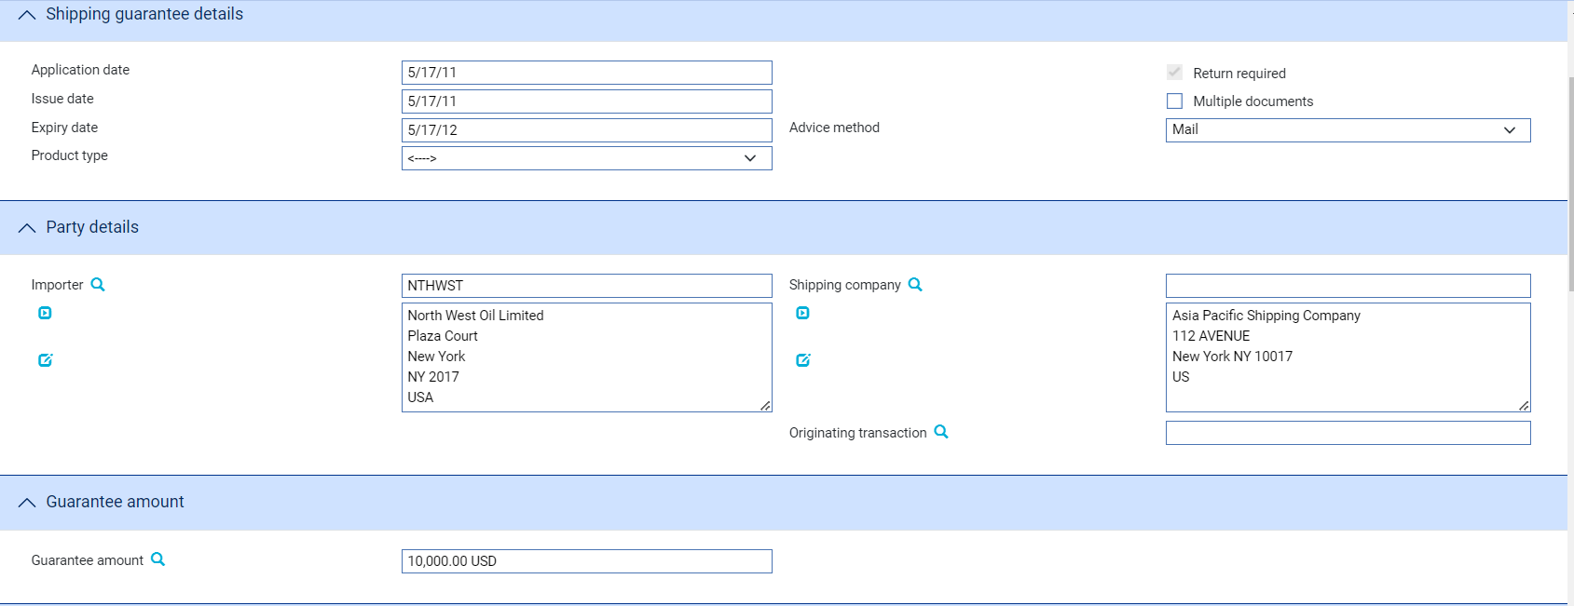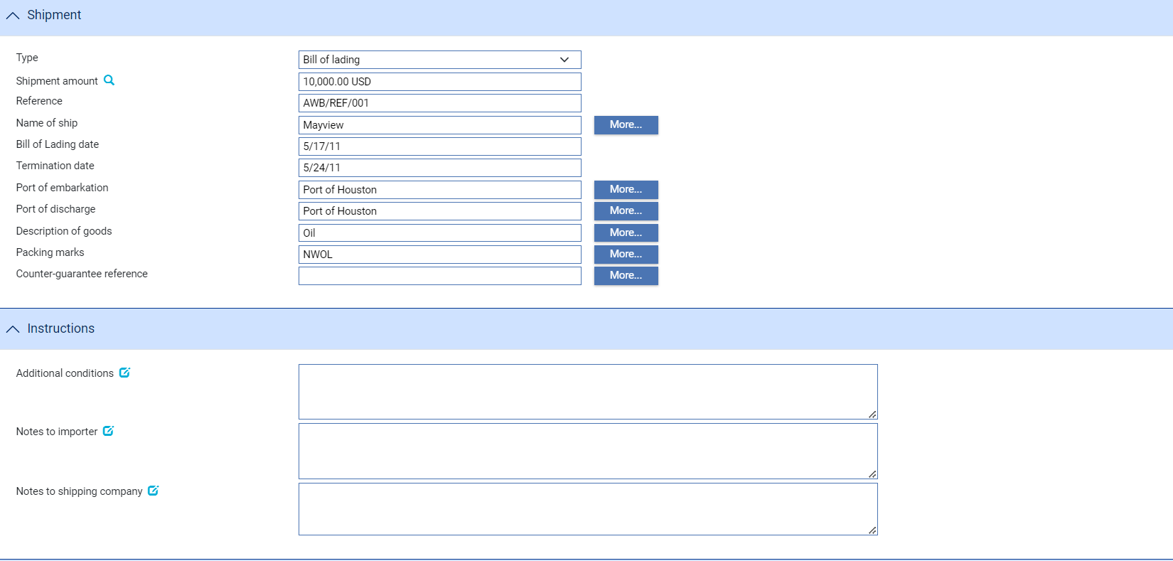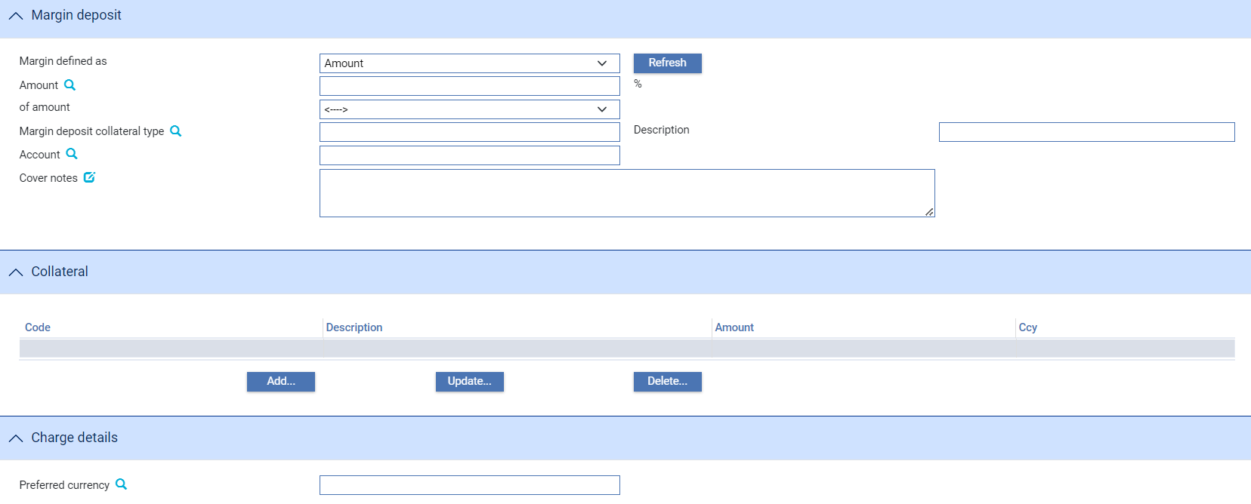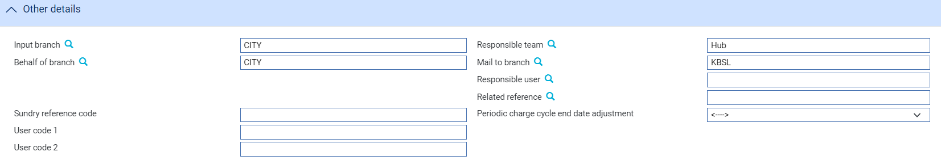

The window used has the following panes:

* The Shipping Guarantee Details Pane (see page 8)
* The Party Details Pane (see page 9)
* The Guarantee Amount Pane (see page 9)
* The Shipment Pane (see page 10)
* The Instructions Pane (see page 11)
* The Margin Deposit Pane (see page 11)
* The Collateral Pane (see the Common Facilities User Guide – Trade Innovation)
* The Charge Details Pane (see page 12)
* The Other Details Pane (see page 12)

### The Shipping Guarantee Details Pane

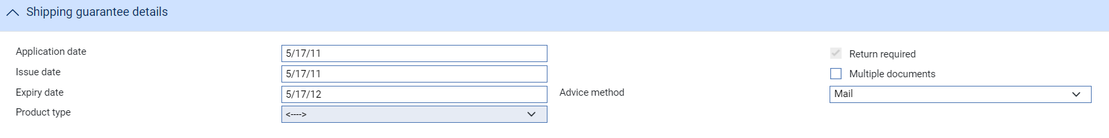

The following table explains what to enter into the fields in the Shipping Guarantee Details pane:

|  | Field | What to Enter |
| --- | --- | --- |
|  | Application Date | The date the consignee applied for the shipping guarantee. The default is the current processing date. |
|  | Issue Date | The date the shipping guarantee was issued. The default is the current processing date. |
|  | Expiry Date | The date on which the shipping guarantee will expire. If you leave this blank the system will calculate the expiry date, using a default expiry period set up for this purpose. |
|  | Product Type | If your bank has set up product types for shipping guarantees, select the appropriate one from the drop-down list on this field. Depending on how your system has been configured, this field may be mandatory. |
|  | Return Required | The Return Required flag is set according to the type of document of title selected. If the document of title selected is an endorsable document then the flag will be checked. |
|  | Multiple Documents | If the shipping guarantee is to cover a single document of title leave this field blank. If it is to cover several shipments, each with a separate document of title check this box.  If your system is configured so that a shipping guarantee can have only one document of title this field will not be available for input. |
|  | Advice Method | The method used to transmit the shipping guarantee to the shipping company. |
|  | Provisional | Check this box if the event is to be treated as ‘Provisional’, in which case a subsequent version of the event is required before the event can be completed. |
|  | Automatically create follow-on event | Checking this box enables the system to automatically create a subsequent version of the event at an Input step; otherwise a new version of the event needs to be created manually. |
|  | Gateway transaction refused | Displayed if the Shipping Guarantee instruction has been received via the gateway. Check this box if your bank wishes to reject the request to create the Shipping Guarantee. |

The Party Details Pane

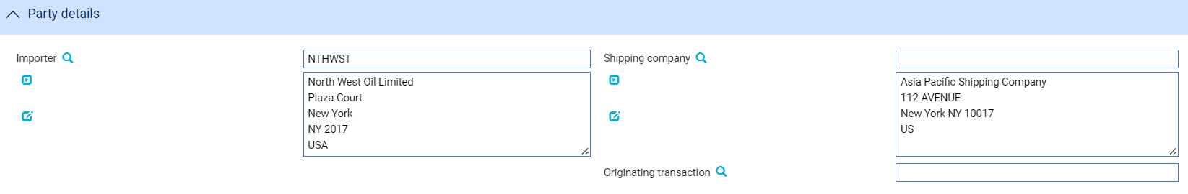

The following table explains what to enter into the fields in the Party Details pane:

|  |  |  |
| --- | --- | --- |
|  | Field | What to Enter |
|  | Importer | The importer. If the shipping guarantee is being created from within an import letter of credit this defaults to the letter of credit's applicant. |
|  | Shipping Company | The shipping company. |
|  | Originating Transaction | For a shipping guarantee which is to cover an existing transaction you can enter your bank's reference for the transaction here. The browser button displays the Masters window, which you can use to identify and select the relevant transaction.  For a standalone shipping guarantee leave this field blank. |

The Guarantee Amount Pane



The Guarantee Amount pane holds a single field used to enter the amount of the guarantee. If the shipping guarantee is being created from within an import letter of credit you may be prevented from entering an amount greater than that of the import letter of credit. (This is controlled by the ShipGteePreventBeingGreatertThanLC system option.)

If the shipping guarantee involves multiple documents of title, the value in this field is calculated by the system as documents of title are added, and you cannot change it.

The Shipment Pane

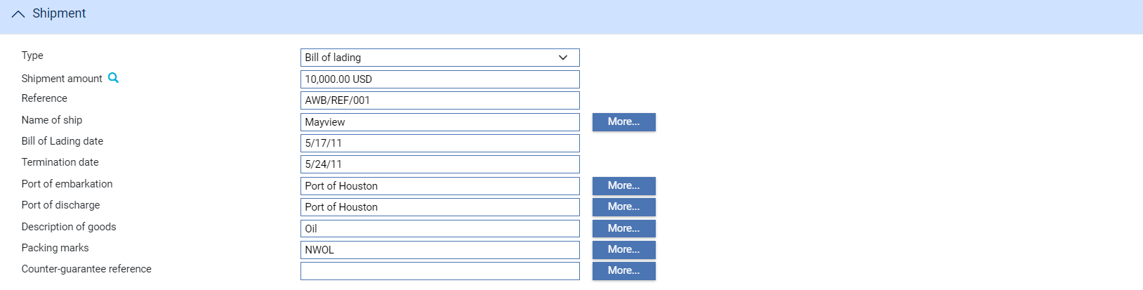

The Shipments pane allows you to enter details of a single document of title. For shipping guarantees with multiple documents of title, check the Multiple Documents field in the Shipping Guarantee Details pane. A new pane is displayed, which you can use to enter several documents of title.

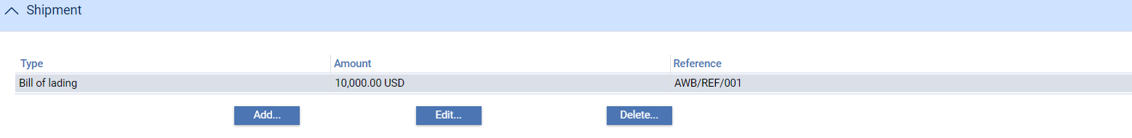

Click **Add** to open a window that allows you to enter details of each of the documents of title in turn.

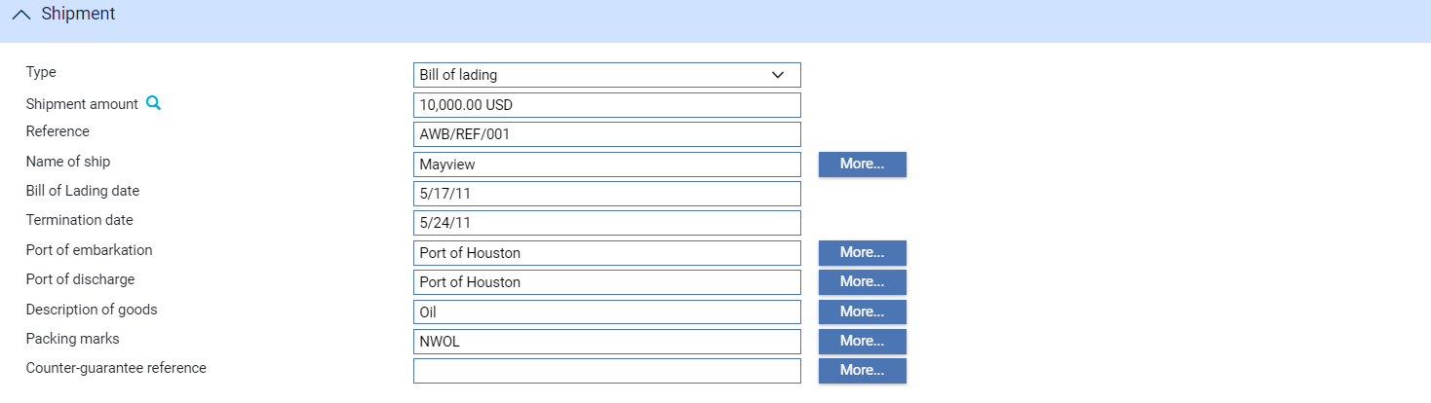

The fields are the same as those used in the Shipment pane to define a single document of title. When you close the window, the details of the part payment are listed in the Shipment pane, from where you can select them and amend or delete them.

For each document of title, use the Type field to select the type of document, then click **Refresh**. For each type of document of title your bank will have defined at least one additional field to appear in this window. The names of these additional fields, the type of information to be entered into them and whether or not they are mandatory is bank-configurable and thus will vary.

The Shipping Amount and Reference fields are always present and are both mandatory.

Use the Shipping Amount field to enter the value of the shipment being covered by the shipping guarantee, and the Reference field to provide a reference for the document of title. (For a bill of lading, for example, this would typically be the bill of lading number.) This reference will appear on the actual document of title.

The Return Required flag is set according to the type of document of title selected. If the document of title selected is an endorsable document then the flag will be checked.

The **More** buttons display a larger narrative field, in case the standard fields are not large enough for the information you need to enter.

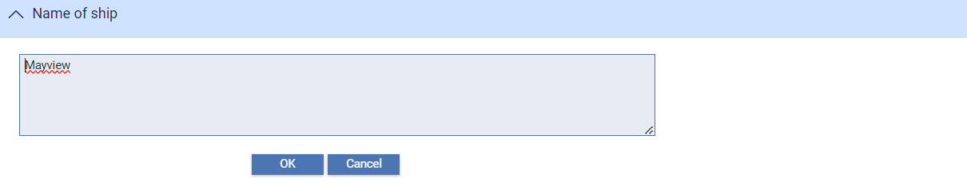

The Instructions Pane

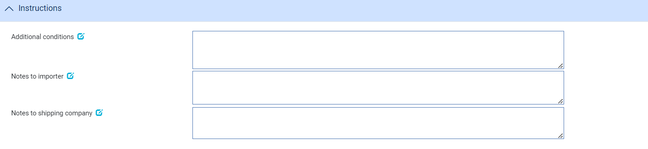

The Instructions pane can be used to enter any additional conditions, or any notes for the importer or the shipping company.

### The Margin Deposit Pane

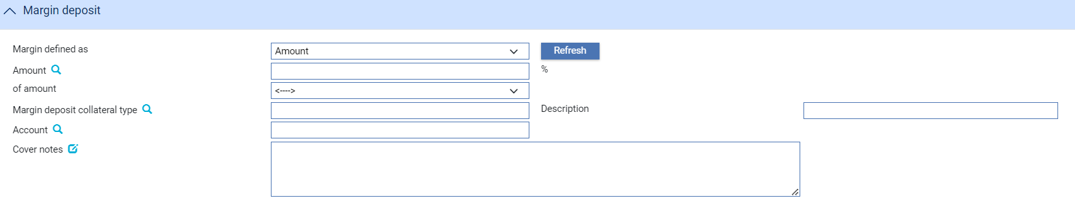

The Margin Deposit pane permits you to enter margin deposit details. Full instructions on what to enter into the fields in this pane are given in the Common Facilities User Guide – Trade Innovation.

An additional field - the Cover Notes field - is present for shipping guarantees and allows you to enter relevant details of the margin deposit or collateral being used as cover for the shipping guarantee.

The Charge Details Pane



The field in the Charge Details pane is used to specify the currency in which the payer's charges will be collected. Typically the payer would be the importer and you would set this to your local currency. If you leave this field blank, the system uses the currency of the shipping guarantee.

The Other Details Pane

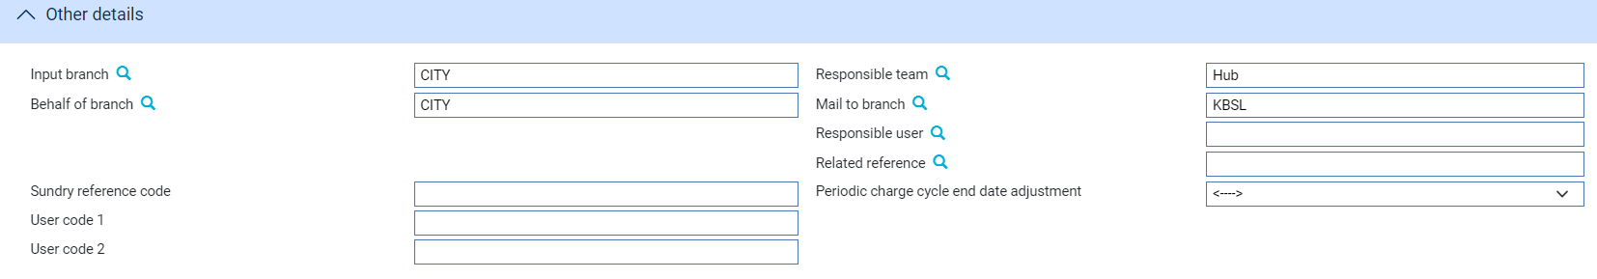

The following table explains what to enter into the fields in the Other Details pane:

| Field | What to Enter |
| --- | --- |
| Input Branch | The input branch for the transaction. The input branch is set from either :   * the accounting branch from the user’s team, or * the transaction branch for user if the user has a default transaction branch or is locked to a specific branch, or * a branch associated with the user where the user can enter transactions for several branches for a team |
| Behalf Of Branch | The behalf of branch for the transaction as entered by the user or set from the incoming SWIFT or gateway message. The behalf of branch determines the parameter sets that are to be used to generate charges, documents, postings, etc. during transaction processing. The branch can be changed to any other branch within the same main banking entity that shares the same parameter sets. |
| Sundry Ref Code /User Code 1/ User Code 2 | You may use these fields to enter values for analysis purposes. Your bank will have devised its own system for using these fields. |
| Responsible Team | The team that has overall responsibility for the master e.g. as the contact to resolve any queries or issues regarding the master and associated events. The system defaults the responsible team when creating the transaction as follows:   * Manual – set from team creating the transaction * Gateway – set from the team specified on the incoming message (if present and valid) otherwise to the team to which the transaction is assigned through workflow allocation based on the behalf of branch * SWIFT – set to the team to which the transaction is assigned through workflow allocation based on the behalf of branch   It can be changed, if required, to either the team associated with the primary customer, default team for the product or the user’s current team. |
| Mail To Branch | The mail to branch can be set to any branch within the main banking entity of the behalf of branch. |
| Responsible User | A user that has responsibility for the master e.g. as the contact to resolve any queries or issues regarding the master and associated events. This can be any user assigned to the responsible team. |
| Related Reference | You can specify any other transaction to which this shipping guarantee is related. |

## The Master Summary Window for Shipping Guarantee

Once you have created a shipping guarantee, the system will display the basic details of that shipping guarantee using the Master Summary window.

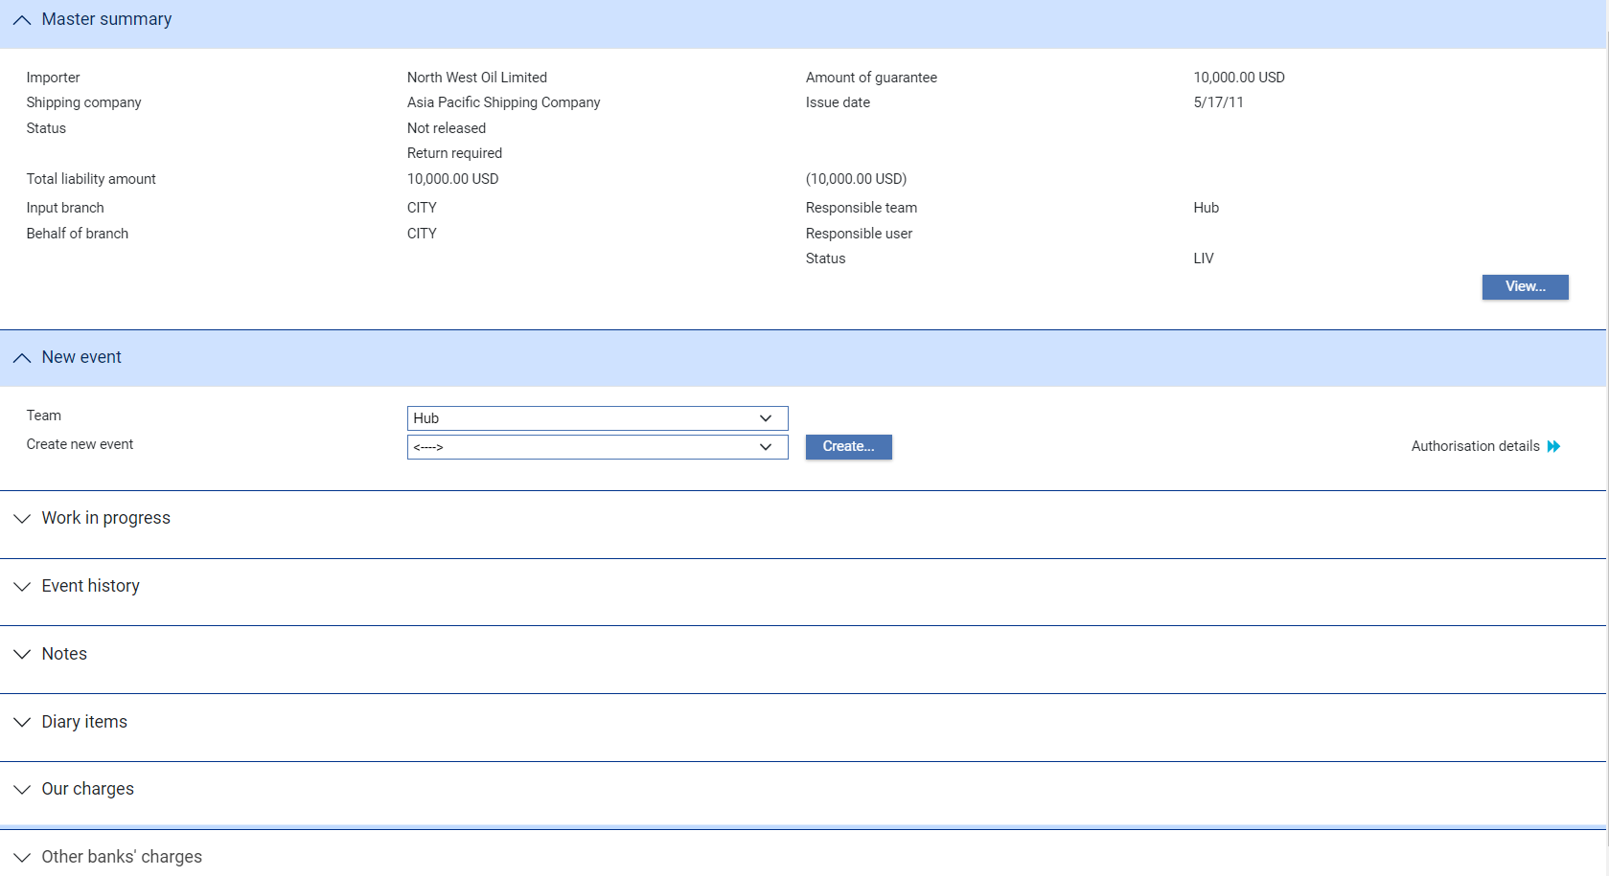

For more information on how the various panes and buttons in this window work see the Common Facilities User Guide – Trade Innovation.

If the shipping guarantee is already linked to a transaction the Related Masters link will display details of that transaction.

## Linking a Shipping Guarantee to a Transaction

Standalone shipping guarantees can be linked to an import letter of credit during the following events:

* Claim Received
* Outstanding Claim

Standalone shipping guarantees can be linked to in inward documentary collection order during the following events:

* Create
* Amend
* Adjust

Each of these events has a pane that is used to identify documents required or received. In most events this pane is called the Attached Documents pane.

In import letter of credit payment events it is called the Documents/Notes pane, and in the Receive Documents event it is called the Documents received pane.

When you click **Add** a second window is displayed. See the Common Facilities User Guide – Trade Innovation for full instructions on using this window.

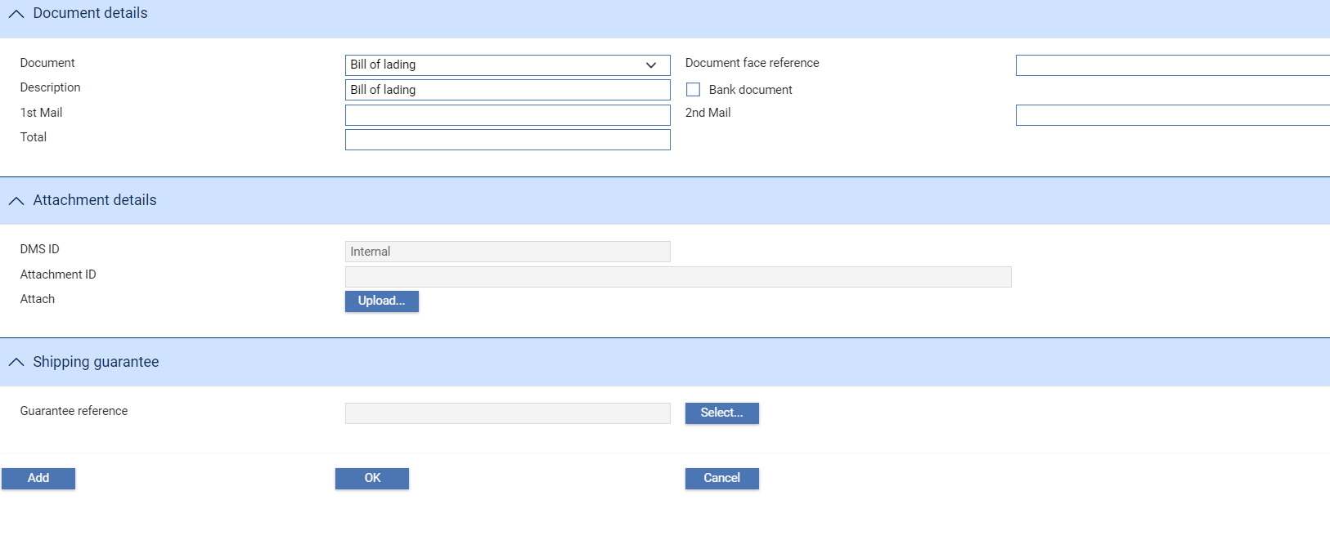

When you select a document of title, an additional pane is displayed - the Shipping Guarantee pane - that allows you to attach one or more shipping guarantees to the transaction. Click **Select**.

In the window that appears, the filters will be pre-set using information taken from the transaction. Reset them, if required then click **Refresh**.

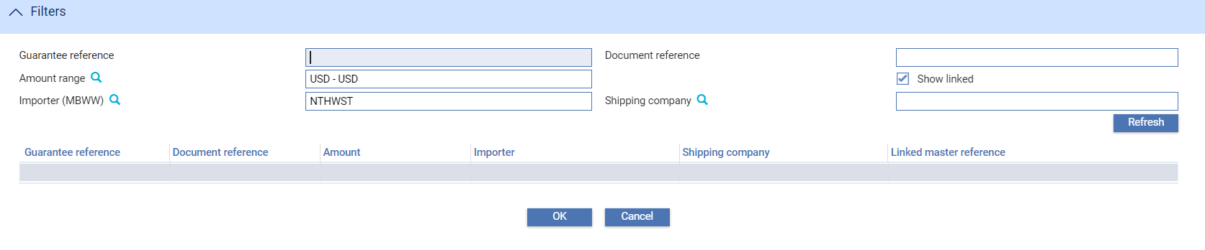

Highlight the shipping guarantee you wish to link to the transaction and click **OK**. The window closes, and you are returned to the previous window, where the details of the selected shipping guarantee are displayed.

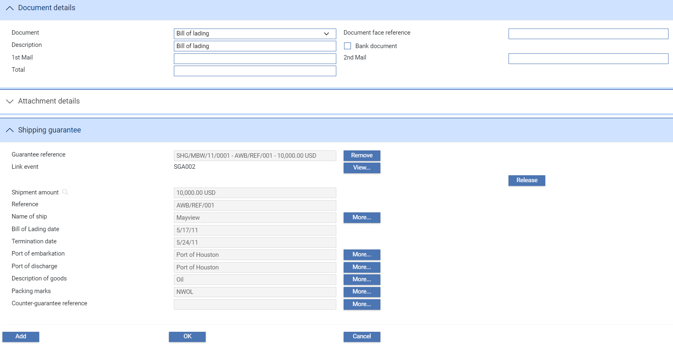

The **Add** button links the selected shipping guarantee to the transaction and clears the window so that you can select the next document of title and associated shipping guarantee.

(The **Release** button is provided here to facilitate the take-on of legacy transactions, and causes the shipping guarantee to be released upon release of the current event.)

Clicking **OK** closes this window. The shipping guarantees you have linked to the transaction are now listed in the main input window.

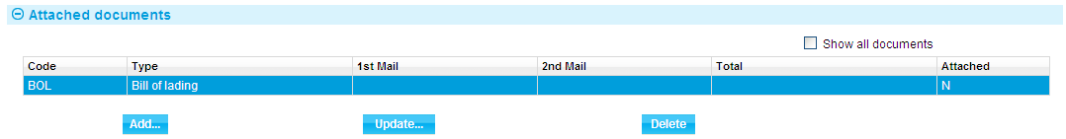

# Recalling a Shipping Guarantee

Once the importer has received the necessary documents of title, these are despatched to the shipping company and the return of the shipping guarantee requested. This is recorded in the system using a Release event. The Release event can only be used to record the despatch of a single document of title - if a shipping guarantee has more than one document of title associated with it you must use separate Release events for each. The shipping guarantee is not returned until the final document of title has been processed.

Release events can be created against the actual shipping guarantee, in which case the import letter of credit or inward documentary collection to which the shipping guarantee refers must be identified.

Release events can also be generated from within an import letter of credit as part of a Claim Received or Outstanding Claim event and from within an inward documentary collection order using the Receive Documents event. Depending on how your system is configured, Release events generated in this way may be released at the same time as the event in which they were created; or they may need to be reviewed.

Your bank will have configured the Release event so that it produces a document for the shipping company requesting the return of the shipping guarantee. This is produced when the Release event completes.

For inward documentary collection orders the Receive Document event allows you to record the receipt of a document of title and its onward transmission to the shipping company, thereby releasing the related shipping guarantee.

## Recalling a Shipping Guarantee from Within a Shipping Guarantee Master

With the appropriate shipping guarantee master open, in the Master Summary window select 'Release' from the Create New Event drop-down list and click **Create**. The system opens the event at either a Log step or Input step. Depending on how your system is configured, panes and fields available in log steps can be tailored for each data capture step. See the *SDK - Screen Tailoring Guide* – Trade Innovationfor details.

The window displayed varies, depending on whether the shipping guarantee involves a single document of title or several documents of title.

For a Single Document of Title

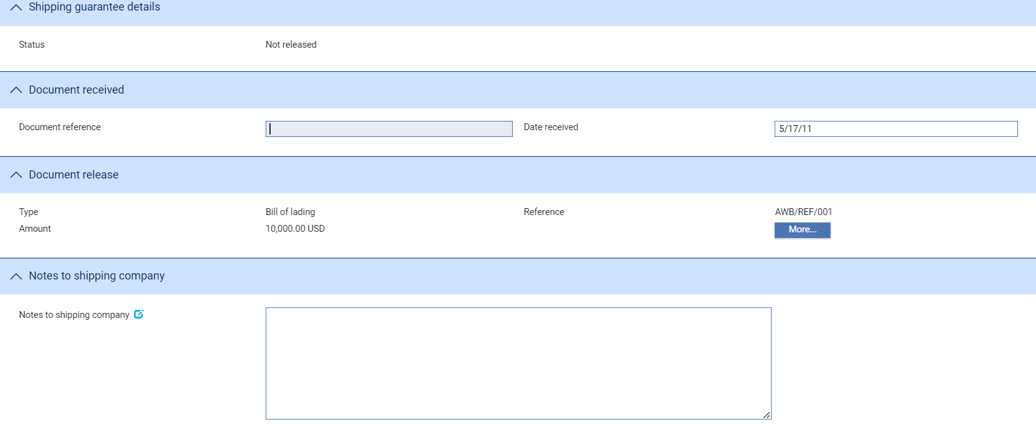

The system automatically picks up the transaction linked to the shipping guarantee. Enter the reference of the document of title you have received into the Document Reference field - this should match the reference entered against the document of title when the shipping guarantee was created. Enter the date that it was received into the Date Received field. Use the Notes to Shipping Company field to enter any narrative for the attention of the shipping company.

The **More** button permits you to view details of the document of title entered against the shipping guarantee and to check that they match the document of title received.

Where There is More Than One Document of Title

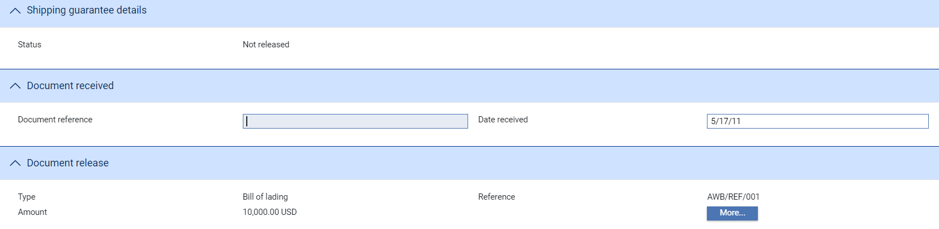

The system automatically picks up the transaction linked to the shipping guarantee. The system lists each of the documents of title entered against this shipping guarantee. Highlight an entry in this list and then click **More** to view the details of the document of title entered against the shipping guarantee and to check that they match the document of title received.

When you have identified the relevant document of title highlight it in the Multiple Document Release pane and click **Received**.

The value in the Received column against that entry changes to show that the document has been received.

Enter the reference of the document of title you have received into the Document Reference field - this should match the reference entered against the document of title when the shipping guarantee was created. Enter the date that it was received into the Date Received field. Use the Notes to Shipping Company field to enter any narrative for the attention of the shipping company.

## Recalling a Shipping Guarantee From Within a Payment Event

A Release event can be generated from within the following import letter of credit payment events:

* Claim Received
* Outstanding Claim

The same windows and fields are used in each case. They are accessed when you click **Add** from within the Documents/Notes pane.

Use the Document Type field to select the type of document of title you have received and use the remaining fields to enter details of mailings or scanned images in the usual way. Once you have selected a document type and clicked **Refresh**, the system displays **Select**, which you can use to select the shipping guarantee to be recalled.

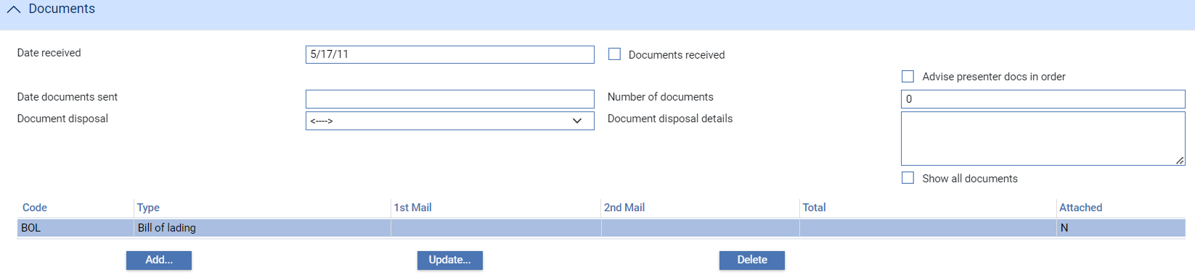

For an import letter of credit that has one or more shipping guarantees set up against it a drop-down field allows you to select the relevant shipping guarantee. Click **OK** once you have done so.

Clicking **Select** produces a Masters window which you can use to select the relevant shipping guarantee. The browser will only retrieve shipping guarantees for the applicant (in the case of an import letter of credit) or drawee (in the case of an inward collection order) that have a document of title defined of the same type as the document type defined here.

Once you have selected a shipping guarantee and clicked **OK** the system displays details of the selected document of title.

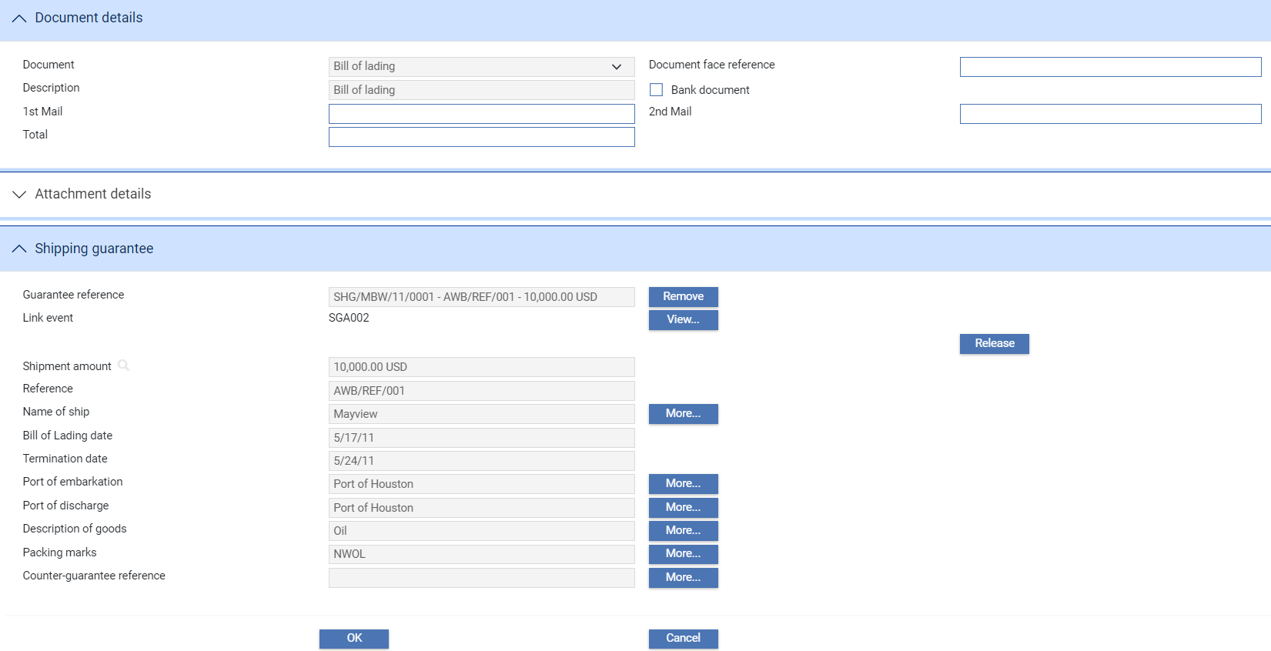

Click **Release** to initiate a subsidiary Release event. The **Release** button is replaced by a **View** button and an **UndoRelease** button.

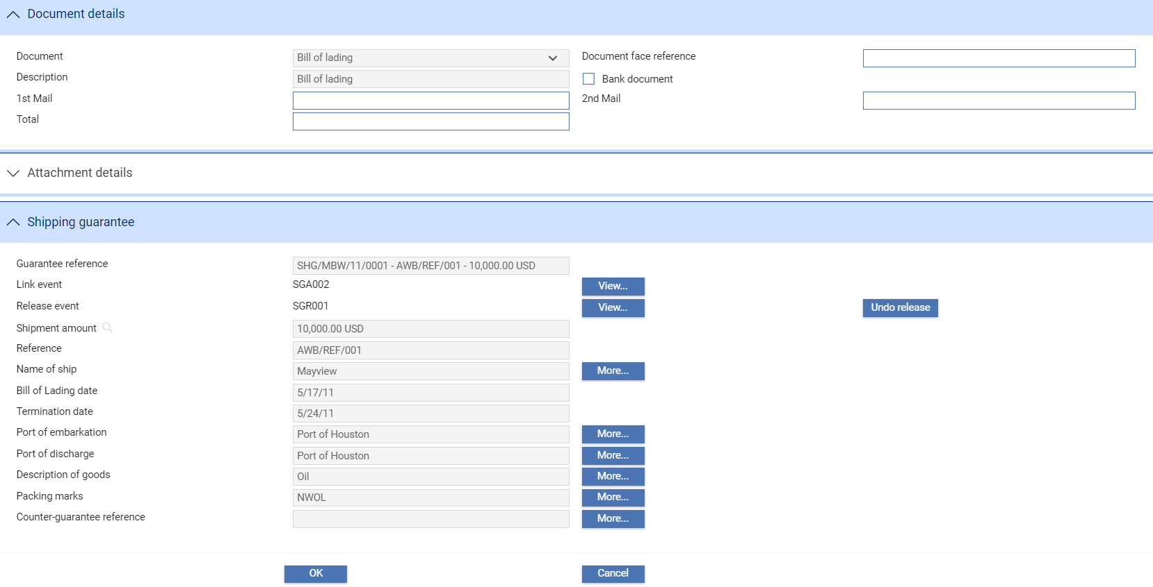

The **Undo Release** button undoes the release action and allows you to select another shipping guarantee. The **View** button displays summary details of the Release event.

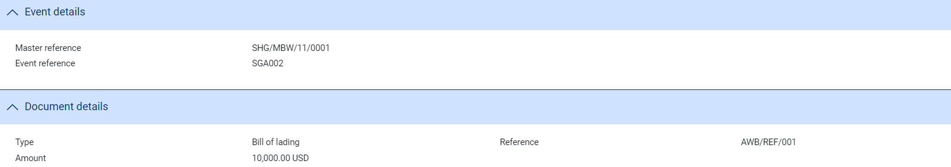

Click **OK** to close the window and return to the main input window.

## Via Correspondence

For inward documentary collections the Receive Document event allows you to record the receipt of a document of title and its onward transmission to the shipping company, thereby releasing the related shipping guarantee.

With the relevant inward collection order master open, in the Master Summary window select 'Receive Documents' from the Create New Event drop-down list and click **Create**. The system opens the event at either a Log step or Input step. Depending on how your system is configured, panes and fields available in log steps can be tailored for each data capture step. See the *SDK - Screen Tailoring Guide* – Trade Innovationfor details.

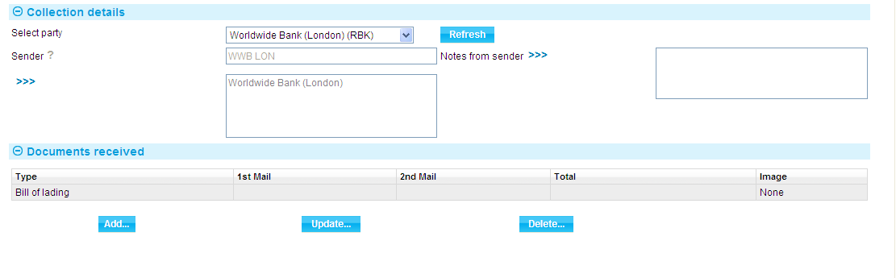

Use the Sender field to select the party from which the document was received. The Notes from Sender field displays any narrative provided by the sender of the document of title.

The Documents Received pane displays details of the document(s) of title defined against the collection order. You can use the buttons in this pane to add, amend or delete entries in the usual way (although you are not able to add a shipping guarantee, if you select a document of title).

Click **Add** and use the Document Type field to select the relevant type of document of title. When you click **Refresh**, **Select** is displayed, which allows you to select the relevant shipping guarantee.

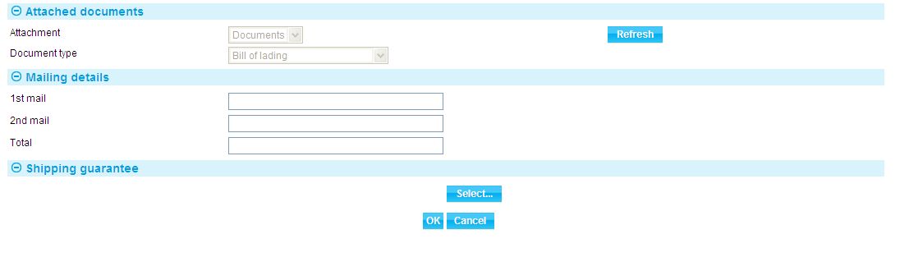

Clicking **Select** produces a Masters window which you can use to select the relevant shipping guarantee. The browser will only retrieve shipping guarantees for the drawee that have a document of title defined of the same type as the document type defined here.

Once you have selected a shipping guarantee and clicked **OK** The system displays details of the selected document of title. Processing is now the same as for recalling a shipping guarantee from within a payment event, described in the previous section.

# Returned Shipping Guarantees

A shipping guarantee is returned once the shipping company has taken delivery of all the documents of title recorded against it. Details of the returned shipping guarantee are entered into the system using a Return event against the shipping guarantee master.

## Recording Details of the Returned Shipping Guarantee

With the relevant shipping guarantee master open, in the Master Summary window select 'Return' from the Create New Event drop-down list and click **Create**. The system opens the event at either a Log step or Input step. Depending on how your system is configured, panes and fields available in log steps can be tailored for each data capture step. See the *SDK - Screen Tailoring Guide* – Trade Innovationfor details.

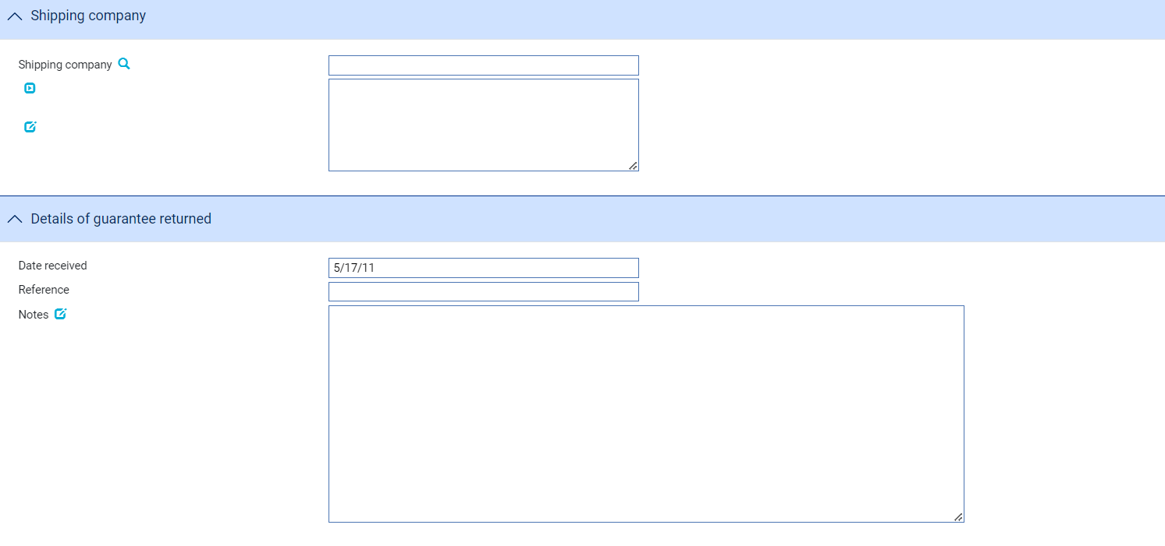

The following table explains what to enter into the fields in this window to record the return of a shipping guarantee. Depending on how your system is configured, the values in the Shipping Company and Reference fields may default to those entered when the shipping guarantee was created. (This is controlled by the SGReferenceAndShippingCoDefault system option.)

|  |  |  |
| --- | --- | --- |
|  | Field | What to Enter |
|  | Shipping Company | The shipping company returning the shipping guarantee. |
|  | Date Received | The date your bank received the shipping guarantee back. |
|  | Reference | Your bank's reference for the shipping guarantee. |
|  | Notes | Any narrative concerning the shipping guarantee and its return. |

# Handling Claims Under the Shipping Guarantee

In the rare event that documents of title are never delivered to the shipping company, the shipping company may make a claim against your bank. The system provides two events to handle such a circumstance:

* The Lodge Claim event (see page 23), which permits you to record details of the claim
* The Settle Claim event (see page 24), which permits you to action payment against a previously recorded claim

You cannot record a claim against a shipping guarantee that has already been fully released; and you can enter only one Lodge Claim and Settle Claim against a shipping guarantee.

You can only settle a claim against a shipping guarantee if there is already a Lodge Claim event completed for that shipping guarantee with an action of 'Accepted'.

## Recording Details of a Claim

With the appropriate shipping guarantee master open, in the Master Summary window select 'Lodge Claim' from the Create New Event drop-down list. The system opens the event at either a Log step or Input step. Depending on how your system is configured, panes and fields available in log steps can be tailored for each data capture step. See the *SDK - Screen Tailoring Guide* – Trade Innovation for details.

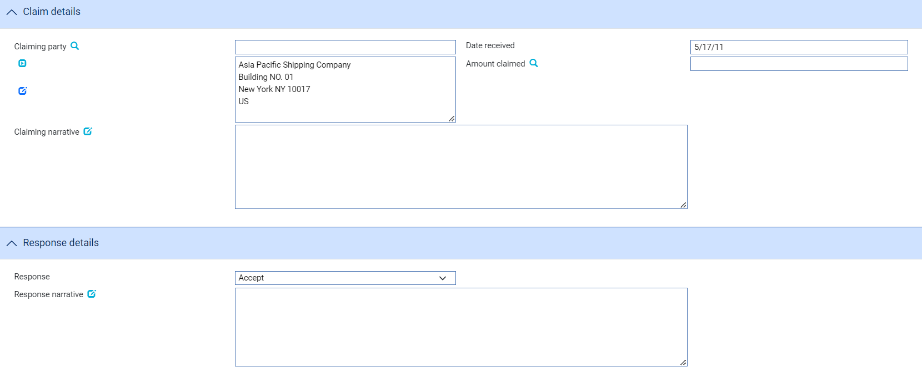

The following table explains what to enter record a claim against a shipping guarantee:

|  |  |  |
| --- | --- | --- |
|  | Field | What to Enter |
|  | Claiming Party | The party making the claim. Typically this will be the shipping company to which the shipping guarantee was issued. |
|  | Date Received | The date your bank received the claim. |
|  | Amount Claimed | The amount being claimed. |
|  | Claim Narrative | Any narrative concerning the shipping guarantee and the current claim. |
|  | Response | Indicate whether you are accepting the claim or rejecting it. |
|  | Response Narrative | Any narrative concerning your response to the claim. |

## Settling a Claim

1. You can only settle a claim against a shipping guarantee if there is already a Lodge Claim event completed for that shipping guarantee with an action of 'Accepted'.

With the appropriate shipping guarantee master open, in the Master Summary window select 'Settle Claim' from the Create New Event drop-down list. The system opens the event at either a Log step or Input step. Depending on how your system is configured, panes and fields available in log steps can be tailored for each data capture step. See the *SDK - Screen Tailoring Guide* – Trade Innovationfor details.

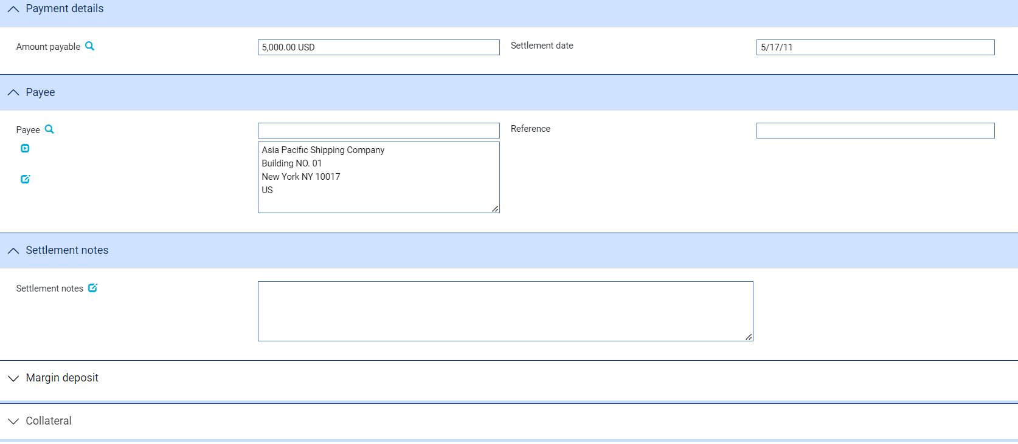

The following table explains what to enter into the fields in this window to record settlement of the claim. See the Common Facilities User Guide – Trade Innovation for instructions on using the Margin Deposit pane and the Collateral pane:

|  |  |  |
| --- | --- | --- |
|  | Field | What to Enter |
|  | Amount Payable | The amount of the claim, with currency. By default this is the amount and currency entered during the Lodge Claim event. |
|  | Settlement Date | The date the payment will be made. |
|  | Payee | The payee. By default this is the claiming party entered during the Lodge Claim event. |
|  | Reference | The payee's reference for the claim. |
|  | Settlement Notes | Any additional information relating to the settlement. |

# Making Changes to a Shipping Guarantee

A shipping guarantee can be amended using an Amend event (see page 26) or an Adjust event (see page 27) at any time between its creation and book-off.

The system permits you to have more than one Amend event in progress at the same time. If you attempt to open an Amend event for a shipping guarantee that already has an Amend event in progress, the system will warn you of the fact, but will allow you to continue. The system will show the current details held for the master when the Amend event is created or opened at an Input step.

If your system is configured so that Amend events need to be reviewed before release, then during these later steps the supervisor will be advised of the existence of another Amend event that has completed while the current event has been at the Review step. They can then decide how each Amend event should be handled to ensure that the required changes are implemented.

## Amending a Shipping Guarantee

With the appropriate shipping guarantee master open, in the Master Summary window select 'Amend' from the Create New Event drop-down list. The system opens the event at either a Log step or Input step. Depending on how your system is configured, panes and fields available in log steps can be tailored for each data capture step. See the *SDK - Screen Tailoring Guide* – Trade Innovation for details.

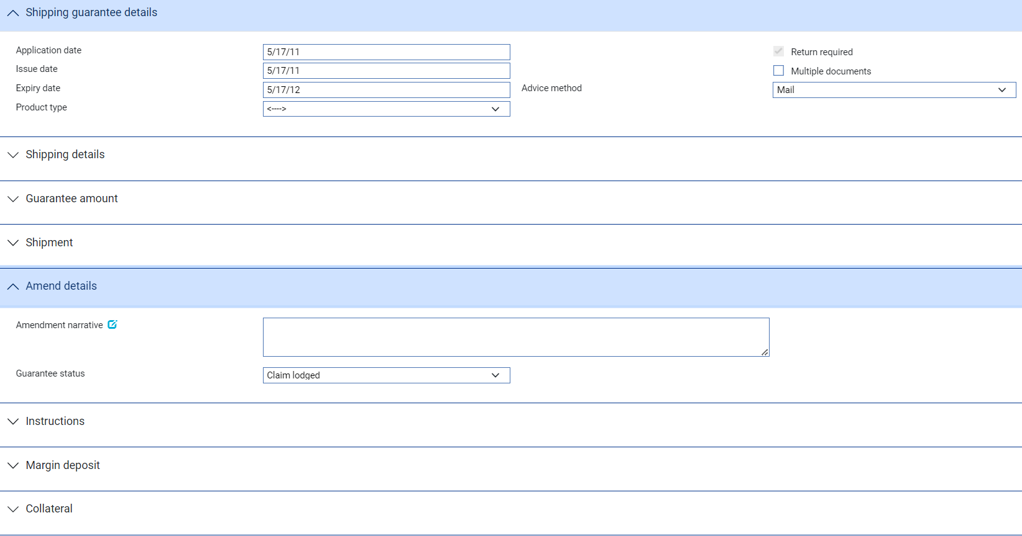

The fields displayed for input are a sub-set of those used when creating a shipping guarantee. The **ViewChanges** button displays details of any changes that have been made in this event.

The Amendment Narrative field permits you to enter any narrative pertaining to the amendment you are making. The Guarantee Status field permits you to amend the status of the shipping guarantee. You can select from the following:

* Not Released
* Partially Released
* Released
* Returned
* Claim Lodged
* Claim Settled

## Making Adjustments to the Master Record

The functionality of the Amend event allows you to make all the changes that are likely to be required in the normal course of business. The system includes an Adjust event, which contains additional functionality to allow you to make changes to all the information recorded for a shipping guarantee, with the exception of your bank's reference number for the shipping guarantee.

The Adjust event is designed to allow you to make changes where you need to alter details but do not need to notify other parties.

This functionally is intended to allow you to correct mistakes, and should be used cautiously. If you make any changes using this functionality, you should ensure that the proper reconciliations are carried out.

With the appropriate shipping guarantee master open, in the Master Summary window select 'Adjust' from the Create New Event drop-down list. The system opens the event at either a Log step or Input step. Depending on how your system is configured, panes and fields available in log steps can be tailored for each data capture step. See the *SDK - Screen Tailoring Guide* – Trade Innovation for details.

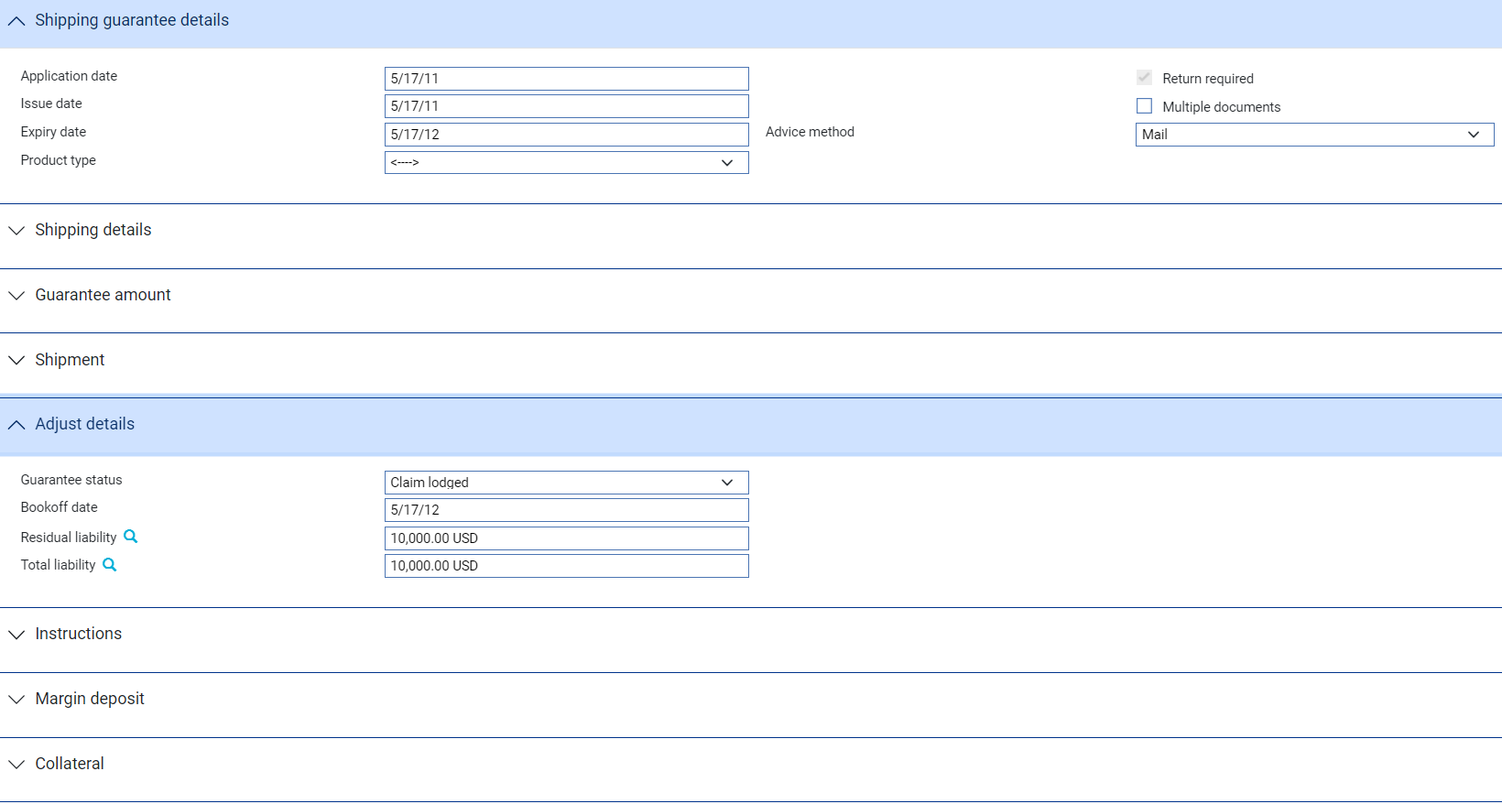

The fields displayed for input are the same as those used when creating a shipping guarantee. The **ViewChanges** button displays details of any changes that have been made in this event.

The Adjust Details pane contains additional fields. The following table explains what to enter into each of these fields, and the implications of what you enter:

| Field | What to Enter |
| --- | --- |
| Guarantee Status | The status of the guarantee, one of:   * Not Released * Partially Released * Released * Returned * Claim Lodged * Claim Settled |
| Bookoff Date | The system displays the shipping guarantee's book-off date, which you can amend. |
| Residual Liability | The system displays the outstanding liability amount as shown on the master record. Use this field to overwrite the figure shown on the master summary if, for any reason, the master figure is incorrect. |
| Total Liability | The system displays the outstanding liability amount as shown on the master record. Use this field to overwrite the figure shown on the master summary if, for any reason, the master figure is incorrect. |

## Displaying Changes

The **Changes** button allows you - and reviewers - to list those fields that have changed within the event.

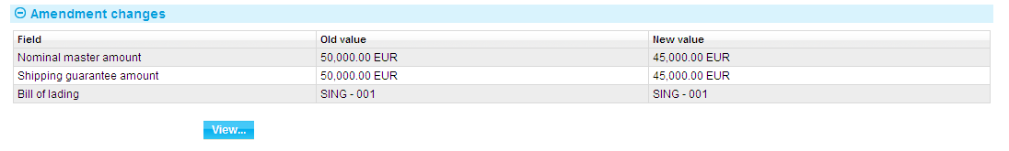

This window is also displayed automatically when an Amend event is opened for review or authorisation.

It lists those fields whose value has changed and shows for each the value before the Amend event and the new value resulting from the Amend event.

For free-format narrative fields, your bank can configure the system so that it shows either the entire content of the field in the New Value column, or just a certain number of lines (defined by the system option ViewChangesLineCount) followed by the text:

>>> plus n more lines. 'View' for details.

where n is the number of additional lines not displayed.

Selecting that entry in the list and clicking **View** displays the entire content of the field.

If you work with this window open, use the **Refresh** button to update the display to show any changes made since you opened the window.